PAGE 8
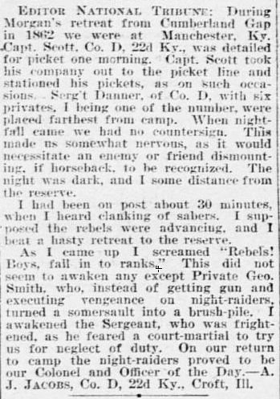
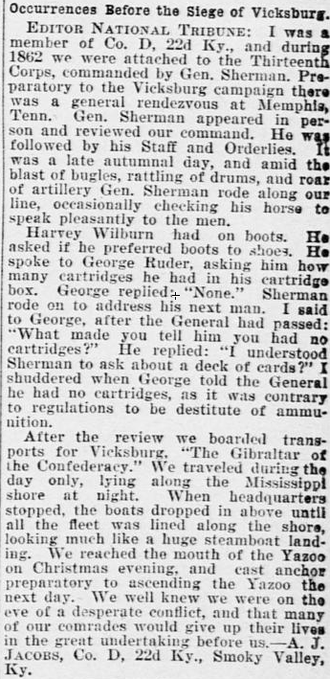
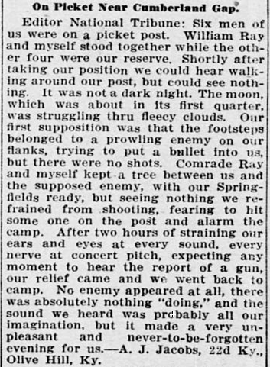
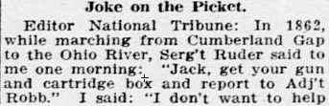
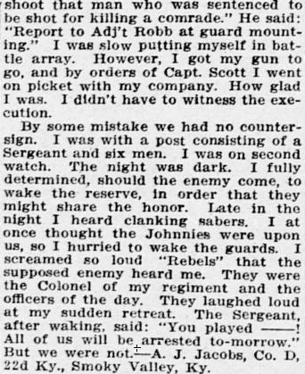
Name in these articles are:
Harvey Wilburn, George Ruder, William Ray, Al Hall, Allen Keeser, Chaplain Sumner, Ralph Ball, Alexander Fraley, Stephen Dehart,Henry Hutchison, Alvin Stewart, John Lester, Capt. O.M. Frazier, Thomas Bellomy, L.S. Rankins, John P. Huff, G.W. Littlejohn

