The House on the Precipices Overlooking the Town of Leon
And stories my mother told me
Mom and I liked to go on “rambles.” We rambled down a road seeking an adventure. Along some of our rambles we recorded her stories. The following pages are an introduction to my mother and a few of her stories.
Contrary to what mom told her grandchildren, when they asked, “Did they have ‘that’ when you went to school?” she really didn’t go to school with George Washington, but she was almost related to him through a distant cousin, Meriwether Lewis. On these pages are histories and stories spanning over twelve generations of our branch of the Lewis family, beginning with William Lewis, b. 1625. But, for me, the Lewis histories and stories began with my mother.
I had set out to find the Meriwether Lewis connection for my mother. Much like Meriwether on his exploration of the northwest, my travels to find my mother’s family connection to Meriwether Lewis has been an adventure of climbing hills and sometimes hitting “rocks,” but always continuing to dig deeper. As I journeyed through the early Lewis’ histories, I found wonderful stories of how so many of them helped to settle and build this great country of ours. However, the most unique Lewis discovery I made along the way, was my mother. I’ve heard stories many times of her childhood and many times I asked to hear them again and again. It wasn’t until I was putting these pages together that I came to know her better.
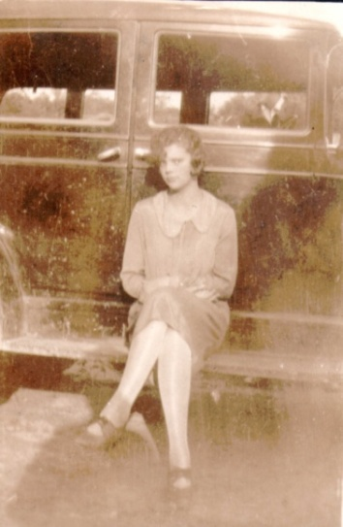
Once upon a time . . . Mom was a little girl. In the early spring months you could see her running through fields of daisies gathering up armloads of the white blooms as she ran along Carter County hills. Mom grew into a beautiful young teenager who attended and graduated from Christian Normal Institute, now Kentucky Christian University. One evening during her teen years, mom and some of her classmates drove to Louisville to unofficially tour around inside Church Hill Downs. On some of the pages that follow you’ll enjoy a commencement speech written in a parody of her fellow high school classmates. Mom was born Dortha Nadene Lewis. My grandmother named her for two of her best friends, Nada and Dene. The Nadene spelling Mom later changed to “Nadine” because that’s the way a famous clothing designer spelled hers; how typical of a teenager! I’m not sure when Dortha became Dorothy. As you explore these pages, I hope you too will get to know the happy and vibrant young girl and teenager who later, blessed my brothers and sister, and her grandchildren as our mom and grandmother.
I invite you to meet my Mom.
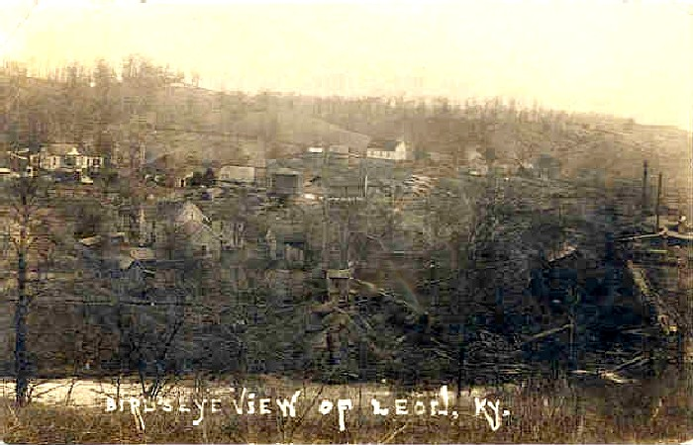
The town of Leon, KY, about 1918

Mom describes Leon:

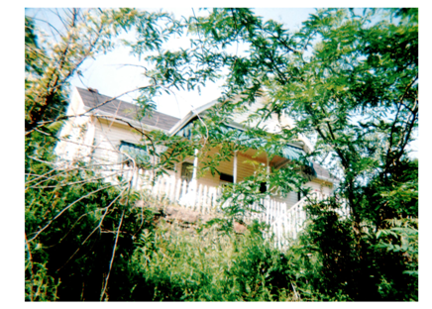The water tank was just a little below our house. The road went along in front of our house, of course, down the hill, we were up on the hill. You went down the steps and there went the road along there. It was the same road that went out in front of the store and was going on a plummet. It went down there along below our house, right in front of our house and the railroad run right along that real close and down just a little way. Right in front of our house over there was a crossing. See they had to have railroad crossings for the wagons and everything. And right below the crossing was the water tank. This was fascinating to see the fast trains pickup their water. There was a thing that the pump man fixed before they got along, they had their regular time and they run on it. And this big arm come over it, it looked like a big wooden arm that come over it and the brakeman or somebody grabbed it and put the water in and that fast train just went flying on and never stopped and took up water because these were steam engines. That was fascinating to see. On up the railroad was a tunnel and just before you got to the tunnel was a pump station, a pump station for the water. And whoever it was kept that tank pumped up full. (I asked, “They pumped water from that point down to the water tank?”) The pump was there, but I expect that the line just came straight from the river. See the river was just straight over back of that too, and down along there too, and the water came from the river. And, I expect the line was there just to come from the river. But his pump house was up the railroad a little bit. I can just see him in my mind’s eye too, a little bitty man, John Damron.

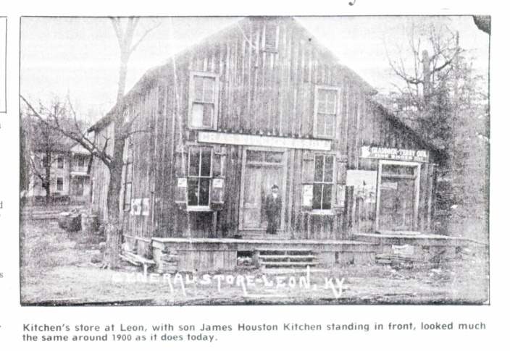
The depot over there, it was a nice depot for that time too. You wouldn’t, but that long ago and that little place it was a nice building. It was a two-story building; it had a nice big waiting room in it. And Tip’s office, he was a telegraph operator too, and of course, he sold tickets and took care of the freight that came in and all that. There was his office and then there on the end of that was a great big storage room for the freight that came in for the farmers to come down and get another time that weren’t there to get it right then. Then they had an apartment upstairs. Pearat’s had an apartment, or whoever lived there; in my time it was Pearats that lived there. They had a nice big apartment upstairs. Tip Pearat, have you ever heard me talk about Parker Pearat? Tip and Mable lived there. Tip was the depot agent and the telegraph operator. (I asked my mom if her dad ever ran the telegraph. I knew that he studied in the School of Telegraphy at what is now called Valparaiso University in Indiana.) I don’t know if Dad ever ran the telegraph or not. He and Tip were real good friends, but I don’t remember if he ever did that. I don’t know if he learned telegraphy or not I don’t remember. I don’t remember him ever using it, because his line was bookkeeping. Tip would have taught anybody, any of the young people around there that wanted to know telegraphy. He was a nice person, and a good man. That was the place for everybody to loaf; around the depot. People would come in and go down and watch the trains come in. They watched who got off and who got on.

The Blue Goose Ride into Grayson:
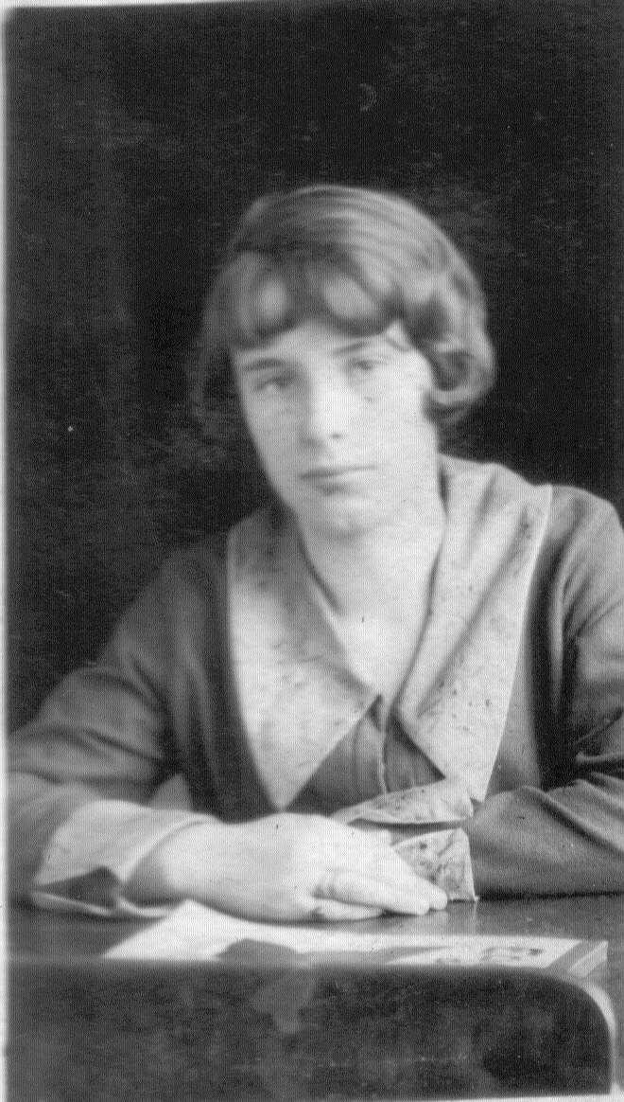
Mom’s school day began early. After she did her chores, she ate a huge breakfast probably consisting of eggs and ham or bacon and biscuits, maybe some gravy too. She then rode horse back to her best friend’s home, Christine. The people living along mom’s path said they could set their watch as Nadine rode past. Mom boarded her horse at Christine’s. Together, the girls walked down to where they could catch the train. A kindly old woman they called Granny Loudenback lived near this point. During the winter months Granny Loudenback would bring the frozen girls into her home and warm them before they caught the Blue Goose into Grayson.
Mom’s best friend,
Christine Brammell Pope Crisp

However, on “court day,” the coach was full of people going to court, either as participants or as spectators. So instead of riding inside the coach, the girls had to ride the Blue Goose hanging on to the outside of it. From the Grayson station, Christine walked to Pritchard High School and mom walked her last miles to Christian Normal Institute (CNI) for her four years of high school.

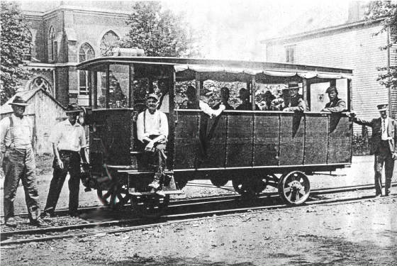

The “Blue Goose” Picture copied from the Eastern Kentucky website: www.ekrailroad.com permission of Website by Terry Baldridge

I Remember the Night that the Bridge Came In:

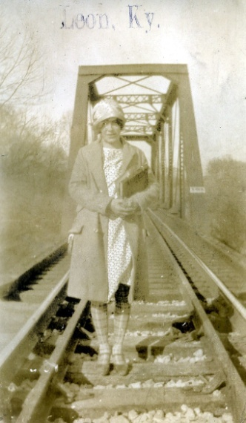
There were people staying at our house. They’d been there for a long time. There was a man and a woman and a grown son. I don’t know how long they’d been there and bridge still hadn’t come in. So the man watched and when the first train would come in, if it were going to set something off on the side, he would always be out there watching. And that night he saw it was a train that was going to put some cars off on the side, and he went to see what it was and it was the bridge coming in. Oh, was there excitement in Leon! They had a big to-do. Everybody was out there looking and everybody was excited. So they could get started on the bridge the next day. They worked all winter on putting that bridge in. That’s when the war was going on, the war to end all wars. We moved to the farm in 1918, in March, when the bridge was new.

The picture was taken at Leon, KY of the EK Railroad Bridge. The picture was taken, maybe around early 1920’s or shortly before.

