The Jenny Wiley Trail (continued)
Primative camp shelters are located along the trail at different intervals. Most shelters have a cistern water supply or a spring or nearby well. All water should be treated.
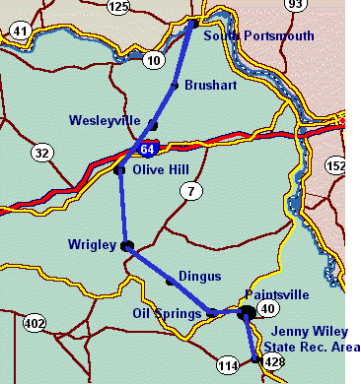
Topographical maps and a trail guide are required for each section of the Jenny Wiley Trail. These maps can be purchased from:
Kentucky Department of Commerce
Map Sales
133 Holes Street
Frankfort, KY 40601
502-564-4715

TRAIL SECTIONS
Click on Section No. to read points of interest

SECTION | DEPART | DESTINATION | DISTANCE
1 | South Portsmouth | Horse Gap  Route 784;  Jct. 7 | 17.9 Miles
2 | Horse Gap | Davis Fork of McGlone Creek  Route 184, Jct. 2 | 19.2 Miles
3 | Davis Gap | Soldier  Route 174 | 23.9 Miles
4 | Soldier | Blairs Mill  Route 711 | 23.5 Miles
5 | Blairs Mill | Crockett  Route 172 | 20.8 Miles
6 | Crockett | Falcon  Route 40 | 24.5 Miles
7 | Falcon | Ivyton | 13.9 Miles
8 | Ivyton | Jenny Wiley State Park | 20.6 Miles
.
Most of the information on this page was gleened from public material produced by Kentucky State Parks, 500 Metro Street, 11th Floor, Capital Plaza Tower, Frankfort, KY 40601.
502- 564-2172

Return to The Jenny Wiley Trail
.
Return to The Story of Jenny Wiley
.
Return to The Wiley Cabin of Walkers Creek
.
Return to Surname Files
Home
.
Ellen Pack
This Page is Copyright 1998 - All Rights Reserved
.

1.
• Overlook of the Ohio River
• Lozier Trail - Privately owned
• Poet Lee Pennington's cabin
• Old Cemetery
Return to Chart
2.
• Portion of trail straddles Greenup and Lewis Counties.
• William's Shelter located in picturesque pastoral setting
• Portions of trail travels through old clay mine
Return to Chart
3.
• Junction of Jenny Wiley and Simon Kenton Trail
• Portion of trail runs along ridge through bountiful ruffed grouse country
Return to Chart
4.
• This area contains a wide variety of wild flowers, ferns, and trees.
• Seasonal waterfalls
• Avoid this section during and soon after heavy rains
• Only section of the trail that is within the Daniel Boone National Forest
• Very scenic area
Return to Chart
5.
• Beautiful scenery, but rough country. Caution advised due to possible bears, and eels in Devi's Fork Creek.
Return to Chart
6.
• Contains remote and primative areas
• Portions of trail follow old Indian trace
Return to Chart
7.
• Shelter contains two bunks.
• Very scenic ridge with rock formations that allow panoramic views into the valleys below.
• Peak trail elevation - 1,425 ft. at Eagle Rock Overlook
Return to Chart
8.
• Various sectons of trail follows ridge.
• Interesting rock formations
• Jenny Wiley is believed to have followed Bear Hollow Creek to the Levisa Fork of the Big Sandy where she crossed the river to the safety of Harmon's Station.
• Beautiful section of trail, but rugged as it climbs and drops.
• Several scenic overlooks.
• Trail passes through a government cemetery.
• Tecumseh Overlook provides grand views of Dewey Lake.
Return to Chart

